Oakland Township Sentinel
Weekly Report – April 26, 2026

Oakland Township Michigan Government
- Factual News and Information
- Suggestions for Improvement

Always free, on-line at https://oaklandtownshipsentinel.com

Contact Information
Contact editor Bob Yager at yagerra@comcast.net, with any editorials, suggestions, criticisms or information the public or officials should know.
About Us
Oakland Township Sentinel is a DBA of Robert A. Yager and Associates L.L.C., Michigan Domestic Limited Liability Company #802404351.

Message for the Week:
- Attend Thursday, April 30, 7 PM Budget Workshop.
- Read about Roads
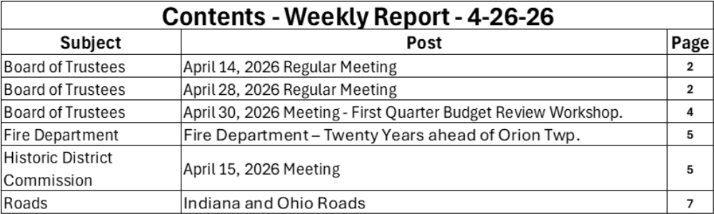

Board of Trustees
April 14, 2026, Regular Meeting
Agenda 753246732.pdf
Minutes 753249409.pdf
Video Board of Trustees - April 14, 2026

April 28, 2026 Regular Meeting
Agenda 753250832.pdf (see below)
Meeting Packet 753250832.pdf 89 pages
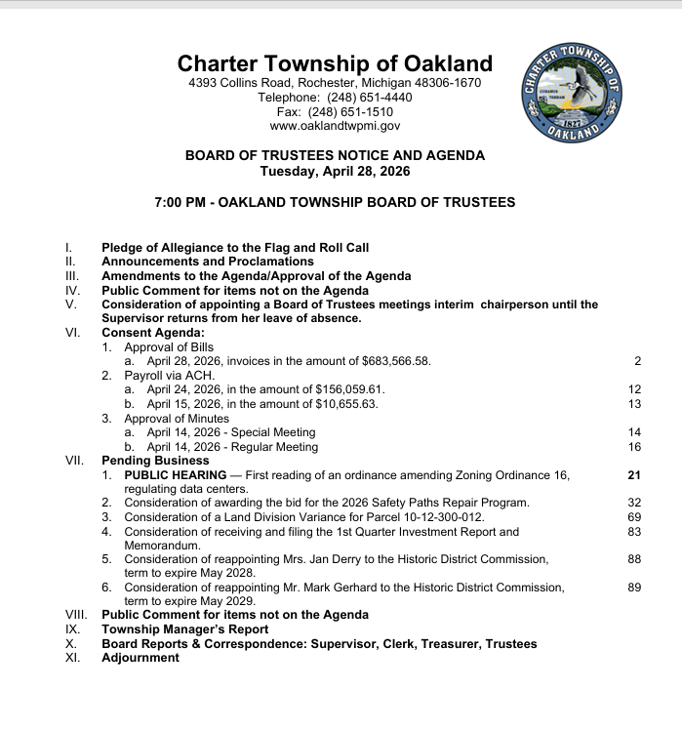

April 30, 2026 First Quarter Budget Review Workshop.
Agenda
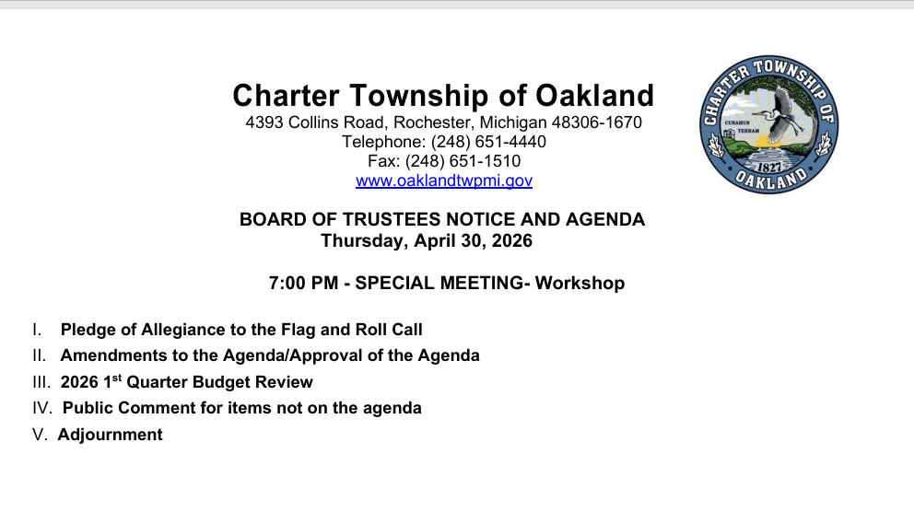
Packet – none
Video- none will be taken
At unrecorded budget workshops you are likely to learn more about our township and our Board than you will ever learn watching a regular meeting.
Attendance is recommended.
Yes, these can be tedious and boring at times, one resident I invited ran from the room as soon as possible.
Everything you want, likely costs money, and Budget Workshops are where suggestions from the Board to itself are made to allocate and reallocate money. Sometimes there are differences of opinion. Which side do you support?
The formal approval of budget changes at Regular meerings, coming from these workshops goes almost unnoticed by the public.
There is public comment. The agenda says “For items not on the agenda”. This is simply an error. You can’t be denied a chance to comment on the budget.

Oakland Township Fire Department – Twenty Years ahead of Others.
Orion Township Board voted April 6, 2026 to put an increase in their Fire Millage from 3.00 to 3.85 mils on the August 2026 ballot. This will be for 3 years. Orion Township, only a few years ago, transitioned from volunteer/paid-on-call and private ambulances to full-time Firefighter/Paramedics and Advanced Life Support. There was only one private ambulance service for Orion.
Oakland went to Advanced Life Support in 2002, because of the leadership of former combination Fire Chief/Building Official, Bill Benoit, to replace unreliable private ambulances (up to 30 minute wait for attention to your heart attack)

Historic District Commission
April 15, 2026 Meeting
Agenda HISTORIC DISTRICT COMMISSION
Minutes - Not available yet
Video - HISTORIC DISTRICT COMMISSION

Roads in Indiana and Ohio

Here is an Indiana gravel road near a Walmart distribution center just west of Auburn, Indiana I-69 exit. (Google Earth). The green is a gravel road shown in a couple of photos

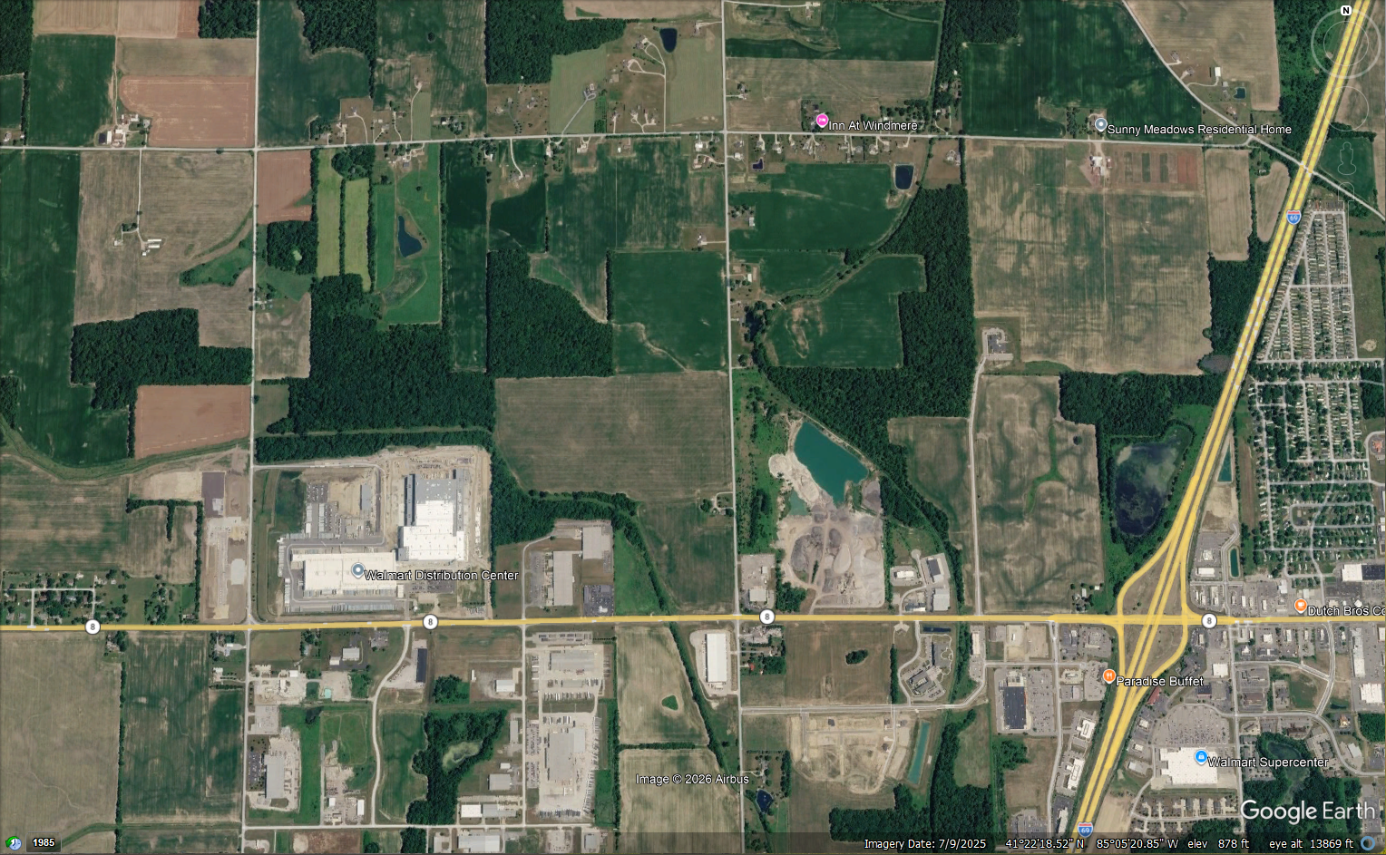
Location of two “photos” on next pages
Auburn, Indiana
Walmart Distribution Center
I-69

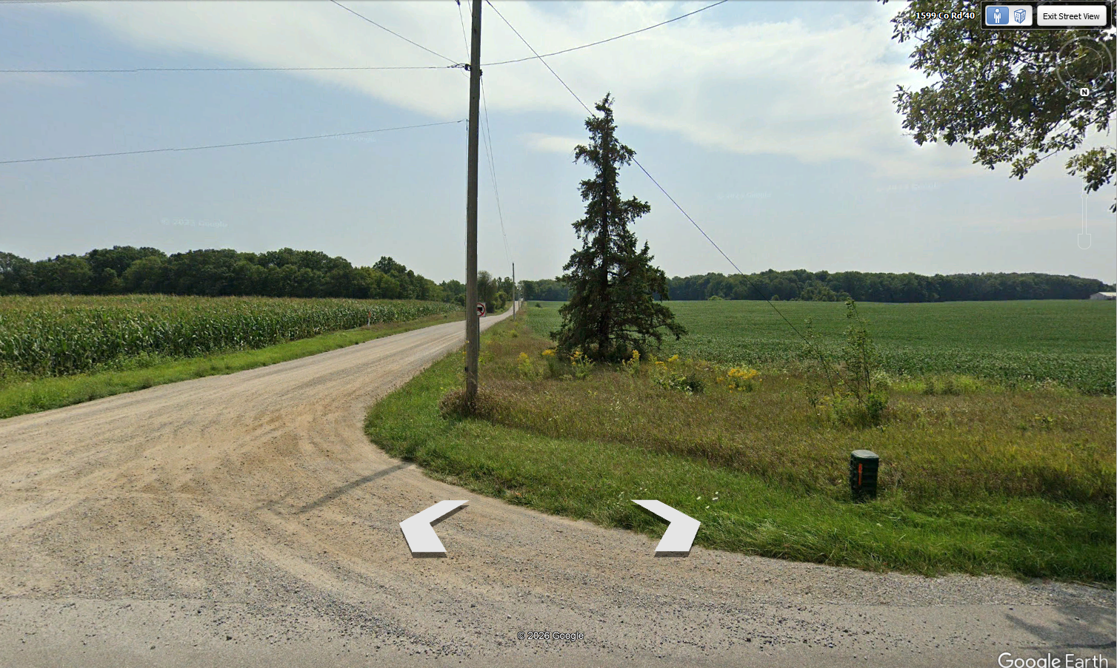
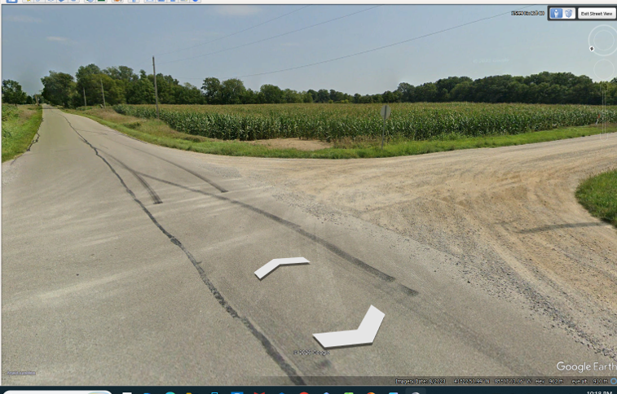

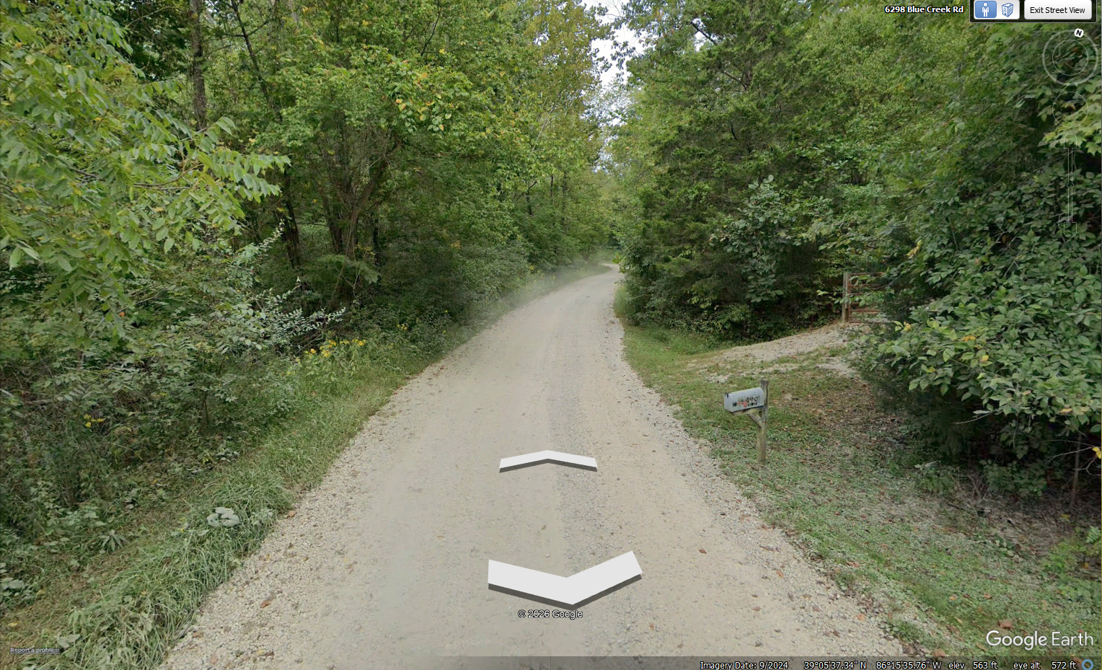
A gravel road in Indiana, southeast of Bloomington. Lots of gravel, no dirt. We drove this to the end last summer, Not one pothole the entire several mile route.

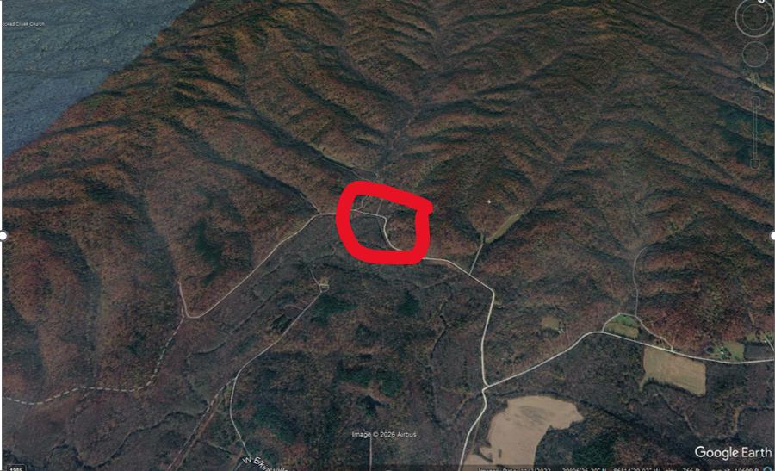
The red circles the area of the previous road shot.

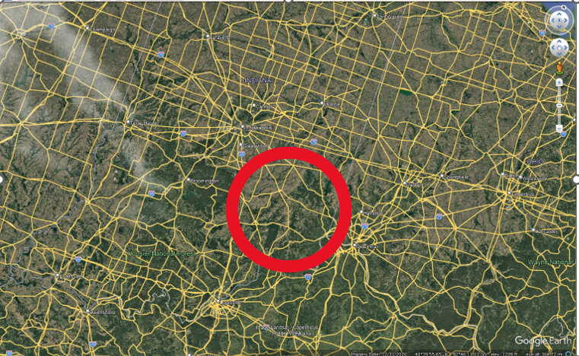
This is the area southeast of Bloomington

All Good Roads in Ohio’s Former Black Swamp
Use googlearth and look at any road in the former Black Swamp. It will be pothole-free and likely paved. My paternal grandfather was born in this area, my wife and I went to BGSU in this area; she lived 18 years as a child in Maumee in this area; we lived 18 married years in Sylvania, Ohio in the area. I visited Honda in Marysville as a paint chemist many times in this area. I know these roads.
Great Black Swamp - Wikipedia
